*LAB # 11*

*lab task*

1. Write a MIPS assembly program that take input value and perform bitwise XOR

instruction with mask 0.

**CODE:**

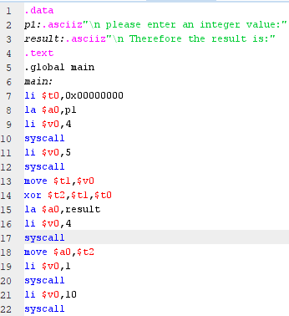

**EXECUTION:**

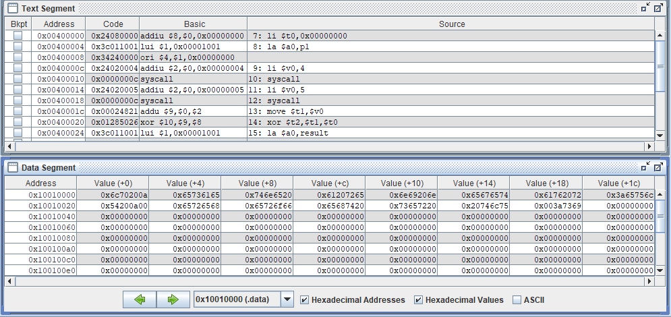

**OUTPUT:**

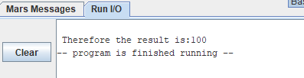

2. Implement following circuits into MIPS Assembly Language using AND, OR

& XOR instructions

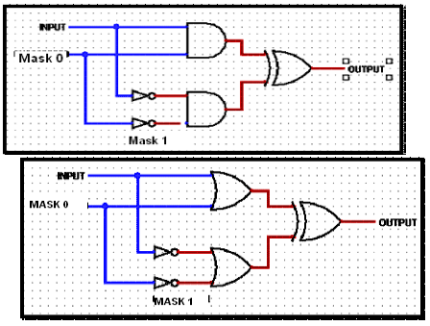

**CODE:**

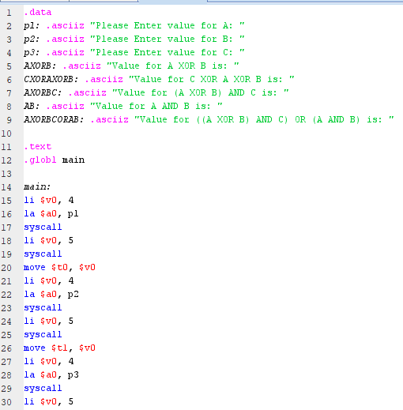

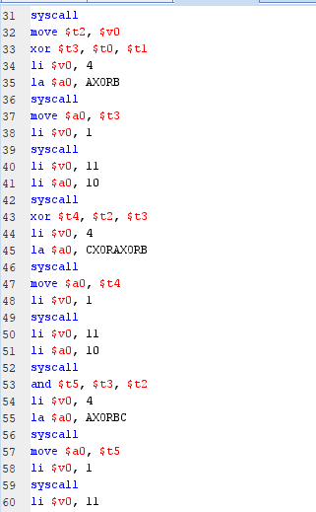

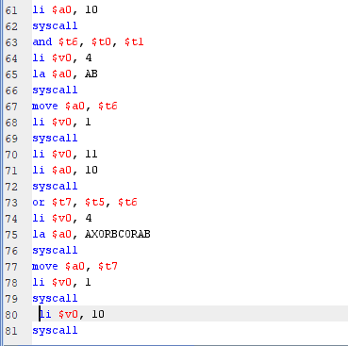

**EXECUTION:**

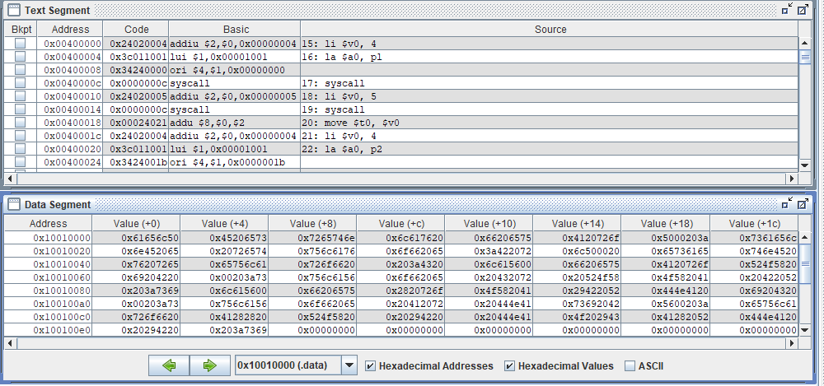

**OUTPUT:**

